Sustainable and Entrepreneurial Finance (FIN-429)

*Professor Eric Jondeau*

**Assignment 2**

**Portfolio allocation** **with ESG/GHG emissions constraints**

“Energy Firms with Available Scope 1 to 3 Emissions”

**Group 8**

Charlotte Ahrens

David Campbell

Guillaume Rico

Per Christian Wessel

1. *Report summary statistics (mean, median, min, max, standard deviation) on the cross-sectional distribution of your group’s variable of interest (i.e. environmental score for groups 1, 9 and 11; social score for groups 2 and 10; governance score for group 3; carbon intensity for groups 4 to 8). Draw the histogram of the cross-sectional distribution of the variable of interest and comment on the summary statistics and the histogram. (10 points)*

The key statistics displayed in Table 1 show that energy companies' carbon intensity varies across different scopes. Scope 1, which represents direct emissions from owned or controlled sources, has the highest mean carbon intensity (618.73) compared to Scope 2 (65.56) and Scope 3 (260.64). This finding is consistent with the intuition that Scope 1 emissions from energy firms are high due to the direct nature of emissions from company-owned sources, related to fossil fuel energy production.

The Indirect Emissions are captured in Scope 3, which encompasses the entire value chain, including activities such as transportation and distribution. Scope 3 (as Scope 1) has a higher mean (260.64) compared to Scope 2 emissions (65.56). This is in line with the energy companies complex and large supply chain. Scope 3 emissions can therefore be significant for energy companies as they represent upstream and downstream emissions associated with the company's suppliers, customers, and end-users.

|  |  |  |  |  |
| --- | --- | --- | --- | --- |
|  | *Scope 1* | *Scope 2* | *Scope 3* | *Scope Total* |
| *# Observations* | *27288* | *27288* | *27288* | *27288* |
| *Min* | *1,04* | *0,00* | *22,47* | *41,74* |
| *Max* | *43437,14* | *2772,09* | *1591,51* | *43839,07* |
| *Mean* | *618,73* | *65,56* | *260,64* | *944,93* |
| *Median* | *280,86* | *36,13* | *239,08* | *622,67* |
| *Standard Deviation* | *1885,77* | *132,49* | *174,16* | *1920,79* |

Table 1 Summary statistics for Scopes 1-3 and Total Scopes for the Energy companies under evaluation.

The data highlights a wide range of carbon intensities (in *tCO2e / million $ revenue*), with the maximum carbon intensity reaching as high as 43’437.14. This suggests that energy companies with carbon-intensive operations may face risks associated with potential regulatory changes, increased costs for emission reduction efforts, like carbon permits, and reputational risks due to increasing concerns about climate change. Such risks can impact the financial performance of energy companies, including increased costs of operations, potential legal liabilities, and constraints in accessing capital due to sustainability concerns of investors. We suspect that this would be captured in the volatility of the highest carbon intensity quintile, which we will investigate later.

The median values for all three scopes 280.86, 36.13, and 239.08 for Scope 1, Scope 2, and Scope 3, respectively are lower than the mean values 618.73, 65.56, and 260.64 for Scope 1, Scope 2, and Scope 3, respectively. This suggests that the distribution of carbon intensity is positively skewed, with a few high outliers that are driving up the mean values. This is important to consider when interpreting the results, as it may indicate that a small number of energy companies have exceptionally high carbon intensities, while the majority have lower carbon intensities. The skewness is visible in the histogram in Figure 1, even with log-transformed data.

Figure 1 Histogram showing the Scope 1-3 and sum of all Scopes for the energy companies

Overall, the statistics highlight the carbon intensity of energy companies across different scopes, indicating variations in emissions from direct and indirect sources. The findings are consistent with existing hypotheses and theories regarding carbon emissions in the energy sector, and financial evidence suggests potential risks associated with carbon-intensive operations. Further analysis considering factors such as regulatory changes, cost of emission reduction efforts, and investor preferences towards sustainability may provide a more comprehensive understanding of the financial implications for energy companies with regards to their carbon intensity. We will investigate these relationships in the upcoming questions by looking at metrics such as volatility and average annual return of the different portfolio quintiles based on carbon intensity.

1. *In Question 4 of Homework 1, you calculated efficient portfolios with various target returns. Take these portfolios, calculate, and report the weighted-average carbon intensity of these portfolios (you can take the average score/carbon intensity for each firm over time). Comment on the carbon intensity of the portfolios. Which firms (e.g., top 10; report firm names along with ISIN) are driving the carbon intensity up? Plot on the volatility-carbon intensity space the various portfolios (i.e., make a plot similar to the efficient frontier except that carbon intensity replaces the return on the y-axis). (15 points)*

Taking the portfolios defined in Homework 1 and computing their respective carbon intensity, we find the following results and the following efficient frontier:

|  |  |  |  |  |
| --- | --- | --- | --- | --- |
|  | Portfolio volatility | Portfolio return | Portfolio Weighted Average Carbon Intensity | Portfolio Sharpe ratio |
| 0.02_portfolio | 13.05% | 2% | 712 | -0.115 |
| 0.04_portfolio | 12.78% | 4% | 719 | 0.039 |
| 0.06_portfolio | 12.62% | 6% | 729 | 0.198 |
| 0.08_portfolio | 12.75% | 8% | 649 | 0.353 |
| 0.1_portfolio | 13.14% | 10% | 618 | 0.495 |
| 0.12_portfolio | 13.77% | 12% | 575 | 0.617 |
| 0.14_portfolio | 14.59% | 14% | 542 | 0.719 |
| 0.16_portfolio | 15.54% | 16% | 540 | 0.804 |
| 0.18_portfolio | 16.76% | 18% | 572 | 0.865 |
| 0.2_portfolio | 18.17% | 20% | 580 | 0.908 |
| 0.22_portfolio | 19.77% | 22% | 596 | 0.936 |
| 0.24_portfolio | 21.65% | 24% | 663 | 0.947 |
| 0.26_portfolio | 23.59% | 26% | 705 | 0.954 |
| 0.28_portfolio | 25.86% | 28% | 738 | 0.947 |
| 0.3_portfolio | 28.64% | 30% | 813 | 0.925 |
| 0.32_portfolio | 31.92% | 32% | 879 | 0.893 |
| 0.34_portfolio | 35.67% | 34% | 959 | 0.855 |
| 0.36_portfolio | 41.46% | 36% | 1463 | 0.784 |
| 0.38_portfolio | 62.68% | 38.4% | 2862 | 0.550 |
| 0.4_portfolio | 67.90% | 38.4% | 3127 | 0.514 |
| 0.42_portfolio | 67.90% | 38.4% | 3127 | 0.514 |
| 0.44_portfolio | 67.90% | 38.4% | 3127 | 0.514 |
| 0.46_portfolio | 67.90% | 38.4% | 3127 | 0.514 |
| 0.48_portfolio | 67.90% | 38.4% | 3127 | 0.514 |

Table 2 Portfolio statistics with carbon intensity.

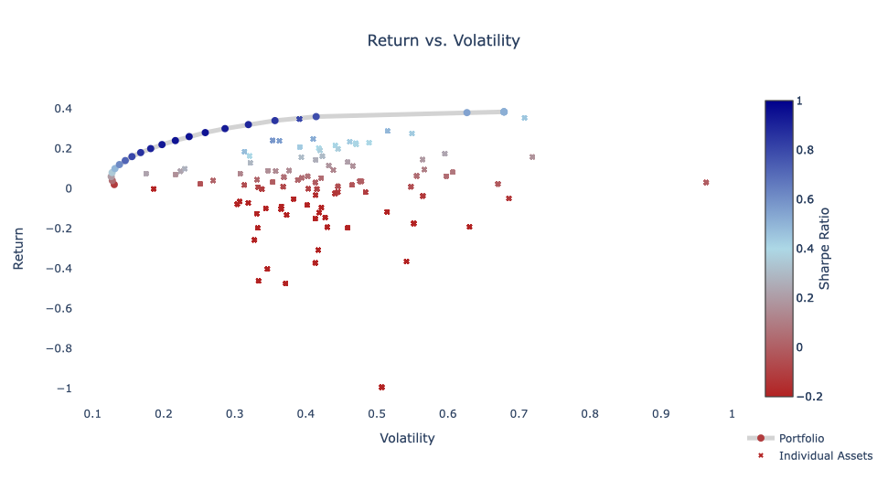

Figure 2 Efficient frontier with individual assets

With a simple glance at the table’s results, a relationship seems to be existing between portfolios’ returns, volatilities and carbon intensities. Indeed, as expected for volatility when plotting a standard efficient frontier, carbon intensity, when plotted against returns, seems to decrease up to a given “optimal” portfolio at which it starts increasing again. This can also be shown by plotting the portfolio returns and carbon intensity as if it would be an efficient frontier (see Figure 3). This relationship also highlights the intuition introduced in class that carbon-intensive companies must compensate investors with higher returns to attract them.

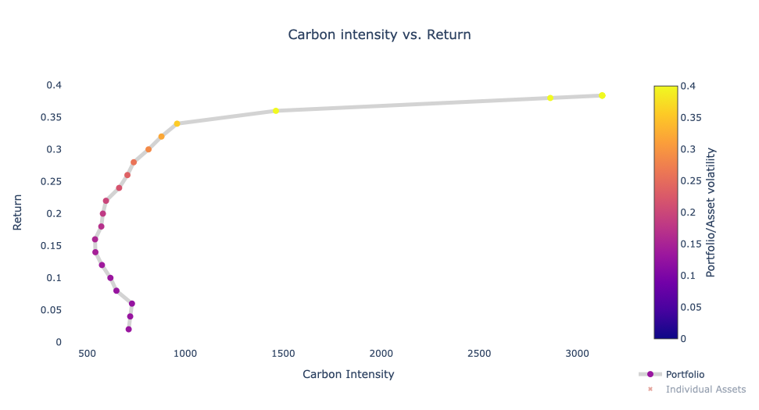

Figure 3 Carbon Intensity to return relationship.

Additionally, this similarity between return and volatility and return and carbon intensity suggests a certain correlation between carbon intensity and volatility. To further investigate this, an analysis of the composition of two specific portfolios – the tangency portfolio (return ≈ 26%) and the minimum carbon intensity portfolio (return ≈ 16%) – will be conducted.

Starting with the tangency portfolio, the following plots and table can better explain the composition of the portfolio and which specific assets drive the return, volatility and carbon intensity of the overall portfolio.

Figure 4 Portfolio composition: 0.26 return

|  |  |  |  |  |  |  |  |
| --- | --- | --- | --- | --- | --- | --- | --- |
| Top 10 | ISIN | NAME | Carbon Intensity | Volatility | Return | Portfolio Weight | Carbon Intensity Impact |
| 1 | JP3142500002 | **IDEMITSU KOSAN** | 840 | 31.37% | 18.43% | 0.233 | -31.315 |
| 2 | KR7010950004 | **S-OIL** | 930 | 35.35% | 24.06% | 0.126 | -28.246 |
| 3 | CNE000001PQ8 | **CHINA MRCH.EN.SHIP. 'A'** | 1385 | 41.39% | 14.35% | 0.030 | -20.564 |
| 4 | RU000A0B90N8 | **RASPADSKAYA** | 3127 | 67.90% | 38.38% | 0.003 | -7.615 |
| 5 | INE029A01011 | **BHARAT PETROLEUM** | 774 | 47.09% | 22.00% | 0.045 | -3.111 |
| 6 | IT0000433307 | **SARAS** | 1112 | 39.18% | 20.73% | 0.000 | 0.000 |
| 7 | LU0156801721 | **TENARIS** | 1731 | 44.51% | -1.85% | 0.000 | 0.000 |
| 8 | ARP9897X1319 | **YPF** | 1392 | 41.89% | -12.10% | 0.000 | 0.000 |
| 9 | US12653C1080 | **CNX RESOURCES** | 1672 | 45.89% | -19.59% | 0.000 | 0.000 |
| 10 | US8454671095 | **SOUTHWESTERN ENERGY** | 1068 | 41.33% | -37.21% | 0.000 | 0.000 |

Table 3 Top 10 carbon intensity: 0.26 return.

As one can see for the tangency portfolio, the volatility and return of the portfolio is heavily influenced by one asset presenting a low carbon intensity compared to its return (bright yellow dot on Figure 4). In terms of volatility, the highly weighted assets are in the middle range. Yet, as it can be seen in the table above, this portfolio still heavily relies on two assets (Idemitsu Kosan & S-Oil: two big dots above the dotted line on Figure 4) that have an absolute carbon intensity higher than the portfolio carbon intensity. Lastly, it might be interesting to acknowledge that a very carbon intensive asset (Raspadskaya) is also part of the portfolio mix.

On the other hand, a comparison with the portfolio with the least carbon intensity is needed. This portfolio’s carbon intensity is 25% lower than tangency portfolio’s. In this sense, it is interesting to further investigate how both portfolios vary in terms of composition.

Figure 5 Portfolio composition: 0.16 return

|  |  |  |  |  |  |  |  |
| --- | --- | --- | --- | --- | --- | --- | --- |
| Top 10 | ISIN | NAME | Carbon Intensity | Volatility | Return | Portfolio Weight | Carbon Intensity Impact |
| 1 | JP3142500002 | **IDEMITSU KOSAN** | 840 | 31.37% | 18.43% | 0.158 | -47.299 |
| 2 | MYL4324OO009 | **HENGYUAN REFINING COMPANY** | 841 | 17.55% | 7.45% | 0.138 | -41.320 |
| 3 | CNE000001PQ8 | **CHINA MRCH.EN.SHIP. 'A'** | 1385 | 41.39% | 14.35% | 0.038 | -32.052 |
| 4 | QA000A0KD6L1 | **QATAR GS.TRAN.NAKILAT** | 1385 | 35.77% | 8.71% | 0.035 | -29.520 |
| 5 | FI0009013296 | **NESTE** | 585 | 39.11% | 34.75% | 0.157 | -7.113 |
| 6 | INE094A01015 | **HINDUSTAN PETROLEUM** | 572 | 46.19% | 23.46% | 0.070 | -2.259 |
| 7 | INE029A01011 | **BHARAT PETROLEUM** | 774 | 47.09% | 22.00% | 0.001 | -0.292 |
| 8 | PK0081801018 | **PAKISTAN PETROLEUM** | 544 | 48.43% | -1.80% | 0.017 | -0.069 |
| 9 | CNE100000528 | **CHINA COAL ENERGY 'H'** | 2785 | 56.48% | -3.73% | 0.000 | 0.000 |
| 10 | RU0007661625 | **GAZPROM** | 2525 | 42.03% | 19.10% | 0.000 | 0.000 |

Table 4 Top 10 carbon intensity: 0.16 return.

Here again (see Figure 5 and Table 4), it does not require a lot of time to understand why both portfolios differ in return but also in carbon intensity. Indeed, while the tangency portfolio was relying on high return assets to reach a relatively high return, this minimum carbon intensity portfolio is based on lower return assets. This lower return can be achieved by combining companies with lower volatility and at the same time lower carbon intensity compared to the other assets. As a result, this low carbon intensity portfolio is reached by including five assets of the bottom 10 carbon intensity ranking (see Figure 5). Interestingly, one can observe that Idemitsu Kosan is also part of the portfolio mix in this portfolio but with a lower weight that in the end is essentially compensated by multiple non carbon intensive assets. Overall, it seems by looking at those results that less carbon intensive portfolios are also composed to a certain extent of lower return/volatility assets.

To get a better understanding of the most/least carbon intensive companies in our 100 randomly selected firms within the energy industry, a top/bottom 10 list can be found in Appendix A.

Finally, when comparing our two portfolios investigated above, one can see that both are more carbon intensive than the bottom 10 assets (based on the dotted line). However, those portfolios are undoubtedly less carbon intensive than the top 10 assets (see Appendix A).

To conclude this analysis of the relationship between return, volatility and carbon intensity, the plot below highlights how carbon intensity evolves with increasing volatility. As already mentioned above, this plot also highlights that higher risk and thus volatility is imputed to more carbon intensive portfolios suggesting that carbon intensive assets might be seen as riskier by investors.

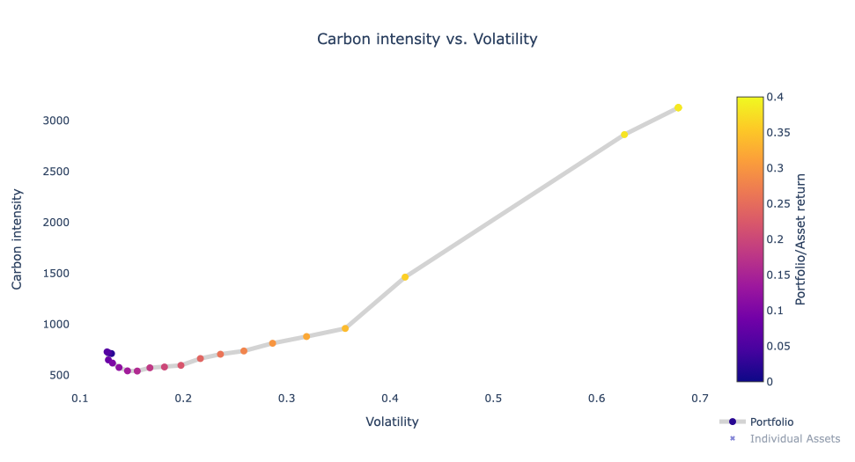

Figure 6 Carbon intensity to volatility relationship.

1. *This question is a follow-up of Question 7 of Homework 1. First, take the same 100 selected firms. Then, create a minimum variance portfolio with monthly rebalancing with an additional constraint: you exclude the worst firms in terms of E/S/G score/most polluting (high carbon intensity) firms Specifically, exclude the bottom tercile of the distribution in month t−1 for ESG scores or exclude the top tercile of the distribution in month t − 1 for the carbon intensity. Report summary statistics on the performance (return, risk, Sharpe ratio) of this portfolio as well as its E/S/G score or carbon intensity. How do the performance measures (return, risk, Sharpe ratio) compare with the minimum variance portfolio from Question 3 of Homework 1. (20 points)*

For this question, we build upon Homework 1 (questions 3 and 7), where we compared the minimum variance portfolio statistics with the minimum variance portfolio where the top third smallest firms based on the market cap were excluded from the portfolio. In addition to the previous task, we now consider the sustainability factor, which is measured by the total Carbon Intensity across all scopes. To select the lowest 67 carbon-intense firms, we sorted the firms based on the Total Scope. We then created a minimum variance portfolio based on the 67 selected firms with monthly rebalancing. Due to limited scope data availability, the period is restricted to five years, from 2015 to 2019.

The goal of this task was to understand the portfolio behavior when excluding the top third, most polluting firms every month. Since the portfolio changes every month, the selection of firms' changes based on the carbon intensity in the portfolio. After we computed the weights of the newly calculated portfolio, we calculated the weighted carbon intensity by multiplying the sum of all scopes with the portfolio weight of each company every month.

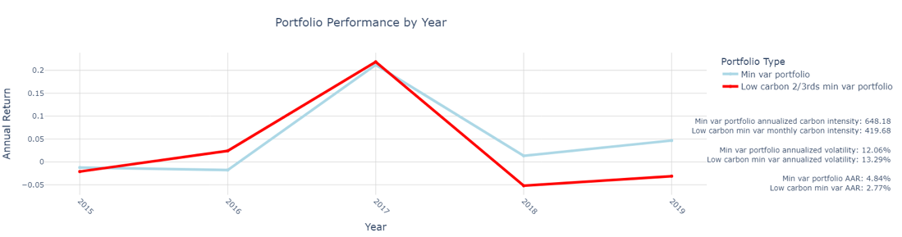

Figure 7 MV portfolio in comparison to MV of lower two-third carbon intense firms over five-year period

Overall, the low carbon 2/3rds min var portfolio follows the same annual return trend as the min var portfolio. In 2015 and 2017 the returns are similar to one another, in 2016 the min var portfolio falls below the return rate of the low carbon portfolio comparison, while in 2018, and 2019 the min var portfolio outperforms the low carbon portfolio in return.

Starting off with interpreting the annualized carbon intensity in (*tCO2e / million $ revenue),* the min var portfolio has a 35% higher carbon intensity compared to the low carbon 2/3rds min var portfolio. This implies that by excluding 33% of the firms and giving more weight to the lowest 67% carbon-intensive companies, 35% of carbon intensity can be removed. By adding this sustainable constraint to the min var portfolio, we can understand the spread of carbon intensity due to extremely high and extremely low carbon-intense assets within our portfolio.

Furthermore, due to the reduction in firms each month, the portfolio is less diversified, which often implies higher volatility, meaning more risk since the investment is spread among fewer firms. This phenomenon can be found in Table 9, where the min var portfolio shows slightly lower volatility (12.06%) than the low carbon 2/3rd min var portfolio (13.29%).

In addition, when comparing the AAR, the return rate of the min var portfolio is 4.84%, which is over two percentage points higher than the AAR of the low carbon 2/3rd portfolio. This can be explained by the fact that more polluting firms also have a higher return to attract investors. It also indicates the tradeoffs between sustainability aspects, return rates, and volatility that an investor must make when deciding to invest in a portfolio.

|  |  |  |
| --- | --- | --- |
| Portfolio | Minimum variance portfolio | Two thirds low carbon minimum variance portfolio |
| AAR: | 4.838% | 2.77% |
| Annualized volatility: | 12.058% | 13.286% |
| Min yearly return: | -1.774% | -5.199% |
| Max yearly return: | 21.199% | 21.86% |
| Sharpe ratio: | 0.111 | -0.055 |
| Carbon Intensity: | 648.177 | 419.682 |

Table 9 Portfolio statistics of MV and MV of lower two-thirds carbon intense firms

The table above displays the key statistics of the portfolios. In addition to the results already discussed above, we will look at the Sharpe ratio, which is a key indicator of portfolio attractiveness since it indicates therisk-adjusted performance of the portfolio. For the min var portfolio, the Sharpe ratio is 0.111, which, although low, is positive, outperforming the risk-free benchmark rate when taking a volatility of 12% into account. For the lower carbon 2/3rd min var portfolio, the Sharpe ratio is negative (-0.055) and with that worse than the benchmark, when taking a risk-free rate of 3.5%. To sum up, the lower carbon 2/3rd min var portfolio is not a financially competitive option to invest in due to its low AAR and its high volatility, both reflected in its negative Sharpe ratio; however, the goal to reduce the impact on carbon intensity has been achieved successfully.

1. *For each month, sort firms based on your group’s variable of interest (E/S/G scores or carbon intensity) into quintiles. Create equally-weighted and value-weighted portfolios for each time period and each score or carbon intensity quintile. Report the average returns for each quintile portfolio as well as a portfolio that goes long in the highest quintile and short the lowest quintile. Comment on your results. What can explain the relationship between the return of your portfolios and firms’ ESG score or carbon emissions? (25 points)*

We started by selecting the same firms as we worked with in Question 2 in Homework 1, but we chose a time period from 2007-2019, as we only had market capitalizations from 2007 and onwards and no carbon intensity data for 2020. We ended up with 105 companies under observation, with non-missing carbon intensity data. This approach helped us to have a clean dataset but would suffer from missing data points, whereas heavy emitters could possibly be missing (assuming that a lack of carbon intensity reporting is considered as bad).

Additionally, we may suffer from a future-backwards perspective that eliminates failed firms, as all our firms have data such that e.g., M&A’s, new listings, and defaults are not captured by the data and would therefore mirror a less natural market. We discussed several strategies to follow the natural pattern of the market, such as only excluding firms that did not have CO2 intensity but had returns and vice versa. This strategy met several challenges, and we chose to work on the clean dataset. We believe our approach is still viable as our main goal is to decarbonize a portfolio, and we are by default interested in companies with consistent carbon intensity reporting.

|  |  |  |  |  |  |  |  |  |  |  |  |  |
| --- | --- | --- | --- | --- | --- | --- | --- | --- | --- | --- | --- | --- |
|  | Equally Weighted Portfolio | | | | | Long - Short | Value Weighted Portfolio | | | | | Long - Short |
| Quintile | **1** | **2** | **3** | **4** | **5** | **1-5** | **1** | **2** | **3** | **4** | **5** | **1-5** |
| Portfolio Intensity | 225 | 472 | 624 | 804 | 2043 | - | 225 | 472 | 624 | 804 | 2043 | - |
| Portfolio Market Cap (US Billions) | 18 | 21 | 39 | 51 | 25 | - | 18 | 21 | 39 | 51 | 25 | - |
| AAR | 8,7% | 8,9% | 7,8% | 7,5% | 5,7% | 0,2% | 9,3% | 12,3% | 10,7% | 7,2% | 7,8% | 2,8% |
| Annualized Mean Volatility | 0,43 | 0,44 | 0,39 | 0,36 | 0,41 | 0,11 | 0,27 | 0,26 | 0,22 | 0,21 | 0,14 | 0,14 |
| Minimum Monthly Return | -31,8% | -23,8% | -21,4% | -23,2% | -30,2% | -9,4% | -25,0% | -19,1% | -15,9% | -15,1% | -15,1% | -15,1% |
| Maximum Monthly Return | 26,0% | 33,2% | 27,3% | 22,8% | 25,0% | 10,2% | 24,9% | 23,5% | 21,9% | 21,4% | 10,6% | 10,6% |
| Sharpe Ratio | 0,12 | 0,12 | 0,11 | 0,11 | 0,05 | -0,29 | 0,22 | 0,34 | 0,33 | 0,18 | -0,05 | -0,05 |

Table 10 Portfolio statistics for different Carbon Intensity Quintiles, Equally- and Value-Weighted, including Long – Short for best and worst Quintile. (Quintile 1: Lowest Carbon Intensity, Quintile 5: Highest Carbon Intensity)

Table 10 highlights key statistics for the different portfolios under observation. We can see that the value-weighted portfolio outperforms the equally weighted in all quintiles except the fourth. The value-weighted portfolio exhibits lower volatility, thus making the Sharpe Ratio drastically better than the equally weighted portfolio across all quintiles. Investing in companies with a large market capitalization within each quintile interestingly gives the best return in the second and third quintiles. The second quintile gives an impressive 12,3% AAR over the 12-year period. There are several factors that could drive this tendency; some energy firms may provide the same products and services thus creating similar emission characteristics and revenue structure, resulting in the same carbon intensity. It could also reflect the fact that being the greenest is very costly, damaging the annual returns. We see that the market capitalization for quintile two is half of quintile three and two fifth of the fifth quintile. This suggests that quintile two contains smaller companies hence with higher expected returns.

Figure 8 Annual portfolio return from 2007 to 2019.

In addition, holding the top or bottom quintile could make the portfolio less diverse, as it limits companies to the extremes, with a very specific carbon footprint. A less diverse portfolio is farther away from the benchmark, thus reducing the expected returns. On the contrary, it’s a clear tendency that the firms with the highest carbon intensity, polluting the most per million USD$, are the worst performers. This is reflected by the fact that quintiles four and five for the equally weighted portfolio and the fourth quintile for the value-weighted portfolio are the losing portfolios (excluding the long-short portfolios). So far, our results support the idea of sustainable investing, where companies with lower carbon intensity may generate better financial performance – at least this is what we find for the companies under observation in the timeframe from 2007 to 2019. To have a more nuanced picture of how each quintile in the value-weighted and equally weighted portfolio performed, we can plot each quintile portfolio across time, displayed in Figure 9. Again, we notice that the equal weighted quintiles exhibit the lowest volatility.

Figure 9 Annual portfolio return from 2007 to 2019 for each Quintile.

Furthermore, the long-short strategy reflects the concept of market inefficiencies, as it attempts to exploit potential mispricing’s between the best and worst performing quintiles based on carbon intensity. In general, going long in the «green» portfolio and short in the «brown», could capture information inefficiency, meaning that not everyone is aware of the potential climate risk facing their portfolio. It could also capture behavioral biases, as investors lean towards «green» over «brown» stocks. Structural factors such as regulatory changes or shifts in public sentiment may not be fully reflected in stock prices, which could be another way of exploiting mispricing’s between the two portfolios.

Figure 10: Annual portfolio return from 2007 to 2019 for the Equally- and and Value Weighted Long-Short portfolios.

In practice, the long-short portfolios will discover the potential loss of eliminating the most carbon intense firms and reveal the potential «greenium», the premium of investing based on «green» environmental values. Intuitively «brown» companies should pay higher returns to attract investors. This is not what we find for the companies under observation. The equally weighted long-short portfolio has an AAR of 0,2%, which can be interpreted such that there is no difference between the two portfolio returns. Quintile 5 has a carbon intensity 10 times higher than Quintile 1, while the difference in the overall portfolio market cap is five billion USD in favor of Quintile 5. This can suggest that the market does not internalize carbon emissions, as it is possible to obtain the same return with a 10 times higher carbon intensity. Hypothetically, if a carbon tax was introduced, these number would look completely different.

On the other side the value-weighted long-short portfolio has an AAR of 2,8% which suggests that the bigger companies yield higher returns when investing in the «greenest» quintile compared to the «brownest» quintile. This could be explained by the fact that large firms have a larger social responsibility thus increasing the risk of not complying with sustainable operation norms and regulations. In conclusion, the findings from the portfolios based on carbon intensity quintiles provide evidence of the relationship between sustainability and financial performance.

1. *Take the minimum variance portfolio from Question 3 of Homework 1 and calculate its E/S/G score or carbon intensity. Reallocate its composition in order to improve the E/S/G score by 20%/reduce carbon intensity by 50% (see optimization problem below). Comment on the changes it took in order to improve the ESG score/carbon intensity (e.g., how many and which firms (firm names) had to be removed in the most recent year of your sample in order to achieve these objectives). (30 points)*

**Calculating minimum variance (MV) portfolio carbon intensity**

When taking our MV portfolio over the 100 random firms and computing the carbon intensity, we get the following characteristics:

|  |  |
| --- | --- |
| AAR: | 4.838% |
| Annualized volatility: | 12.058% |
| Min yearly return: | -1.774% |
| Max yearly return: | 21.199% |
| Sharpe ratio: | 0.111 |
| Carbon intensity: | 648.177 |

Table 11 MV portfolio key characteristics.

Our carbon intensity of *648.177 tCO2e / million $ revenue* was calculated by taking the monthly average scope 1, 2, and 3 intensities of our portfolio firms, multiplying them by their respective monthly rebalanced weights, averaging them so that each scope has its weighted-average monthly scope intensity, and adding them together. For the MV portfolio, this carbon intensity score is driven by scopes 1 & 3, with scope 1 responsible for ~55% of the carbon intensity, and scope 3 making up ~40%.

**Reallocating the composition to reduce carbon intensity by 50%**

As shown above, the portfolio’s carbon intensity is 648.177. We assume that the carbon intensity should be reduced by exactly 50% (as indicated in the instructions), so reducing it by 50% means that our target carbon intensity is 324.089. The optimization problem thus looks as follows:

Objective:

Constraints: and

Concretely, to achieve a reduction of exactly 50%, we used scipy’s minimization optimizer, with the objective function stated above, a first constraint being that the sum of the weights equals 1 for each month, and the second constraint being that the dot product of the weights and the carbon intensity (of scopes 1, 2, and 3 added together) equals the target carbon intensity. We also bounded our weights between 0 and 1 to avoid negativity. Executing this optimization led us to the following results:

|  |  |  |
| --- | --- | --- |
| Portfolio: | MV | Greener MV |
| AAR: | 4.838% | 6.093% |
| Annualized volatility: | 12.058% | 13.311% |
| Min yearly return: | -1.774% | -1.516% |
| Max yearly return: | 21.199% | 22.993% |
| Sharpe ratio: | 0.111 | 0.195 |
| Carbon intensity: | 648.177 | 324.089 |

Table 12 MV & Greener MV portfolio key characteristics.

The carbon intensity of our “Greener MV” portfolio can be attributed to scope 1 emissions with 41%, scope 2 emissions with 9%, and scope 3 emissions with 50%. Compared to this distribution for the original MV portfolio (55%, 5%, 40% respectively), we observe that the optimization punished firms with high scope 1 emissions.

Interestingly, our Greener MV portfolio offers higher annualized average returns than the MV portfolio. This is not particularly surprising, as the optimization problem solely aims at minimizing the variance (and thereby volatility), disregarding returns. However, it does show that lower carbon intensity is not always incompatible with better financial performance. The additional volatility that investors will suffer is not significant, and this is also demonstrated by the higher Sharpe ratio that the Greener MV portfolio exhibits. Here is a visualization of both portfolios’ performance:

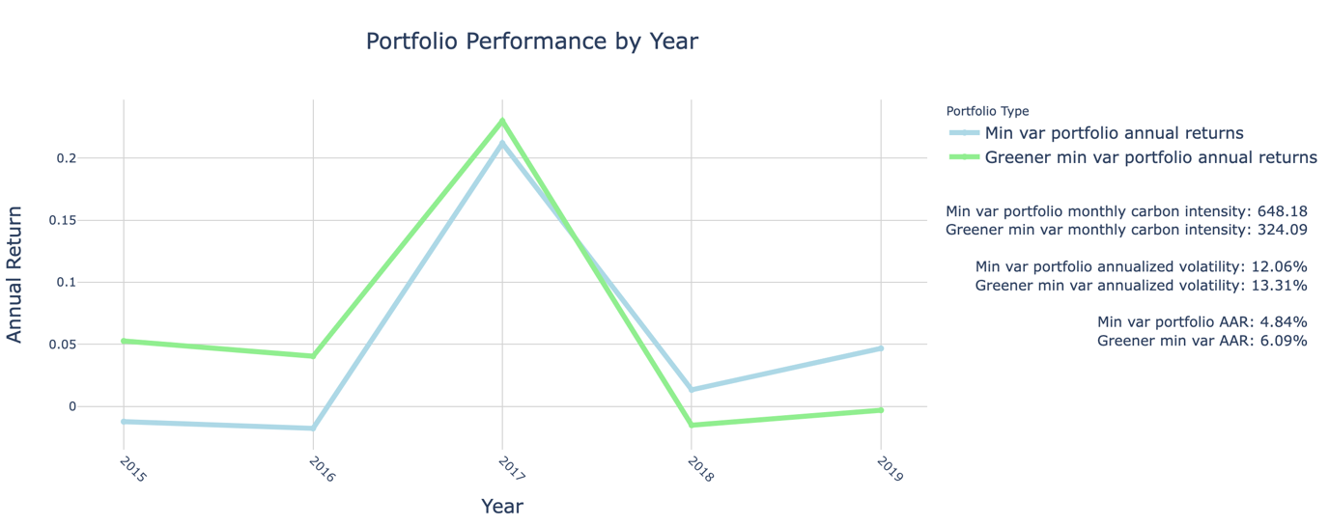

Figure 11 MV & Greener MV portfolio performance 2015-2019

**Commenting on the changes it took to improve the carbon intensity.**

As a first step to analyzing the change in asset weights selected by the Greener MV portfolio, we suggest contrasting the firms’ average weights over time with their “cleanness”. We ranked the firms in our sample by the total carbon intensity that they exhibited (sum of average yearly scope 1, 2, and 3 intensities), with rank 1 being the cleanest firm, and rank 100 being the dirtiest firm. We then computed the correlation between the average portfolio weight given to the firms with their cleanness rank. We expected a negative relationship between cleanness rank and average weight for the Greener MV portfolio, as the weight should decrease with a “higher” rank (e.g., we would like the firm ranked #100 to have a very small or zero weight). Here are the correlations for both the MV and Greener MV portfolios:

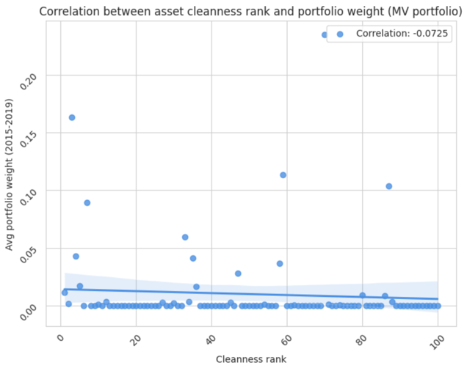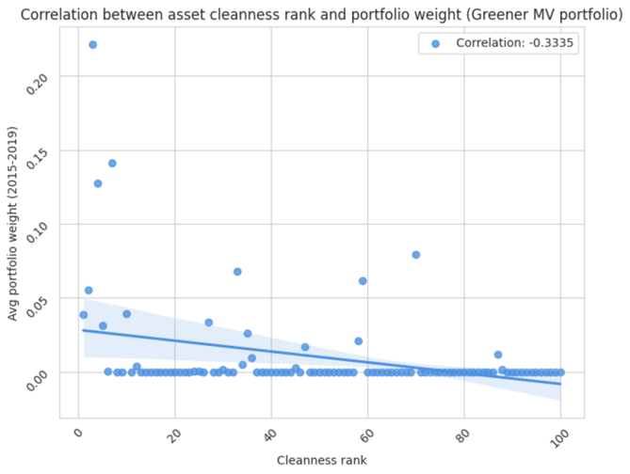

Figure 12 Relationship between cleanness rank and average portfolio weight for the MV & Greener MV portfolios

As expected, we find a negative correlation (-0.3335) between cleanness and average weight for the Greener MV portfolio, while the correlation is unsurprisingly close to 0 (-0.0725) for the MV portfolio.

In the second step of the analysis, we focus on the last year of the portfolios; 2019. We calculate the average weight that both portfolios gave to each firm in 2019, which allows us to compute the percentage change in weight that each stock underwent from the MV portfolio to the Greener MV portfolio. Among firms that had both the MV weight and Greener MV weight (firms that aren’t largely unutilized by both portfolios), we display the 10 that have the largest *positive* percentage change in weight between the MV and Greener MV portfolio below[1]:

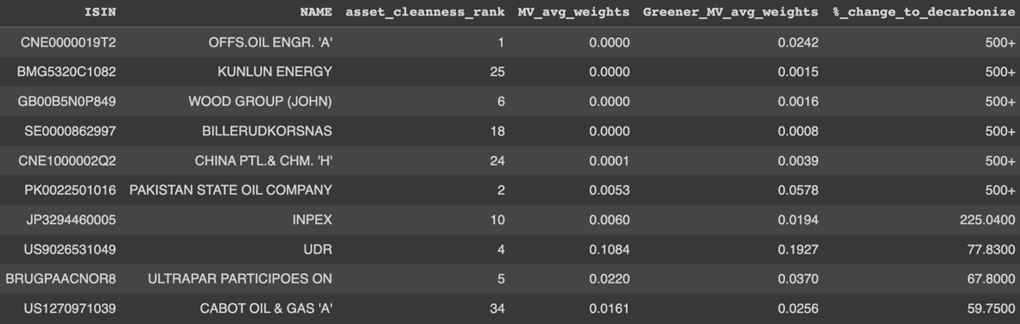

Table 13 Top 10 firms in terms of % change of average weight between the MV and Greener MV in 2019

The first 5 firms among those in the table above had weights that were very close to 0 in the MV portfolio, and which grew significantly in the Greener MV portfolio (500+ %). As shown in the “asset cleanness rank” column, these firms have very good cleanness rankings (average 12.9). The table below, by contrast, shows the 10 firms that have the largest *negative* percentage change in weight between the MV and Greener MV portfolio:

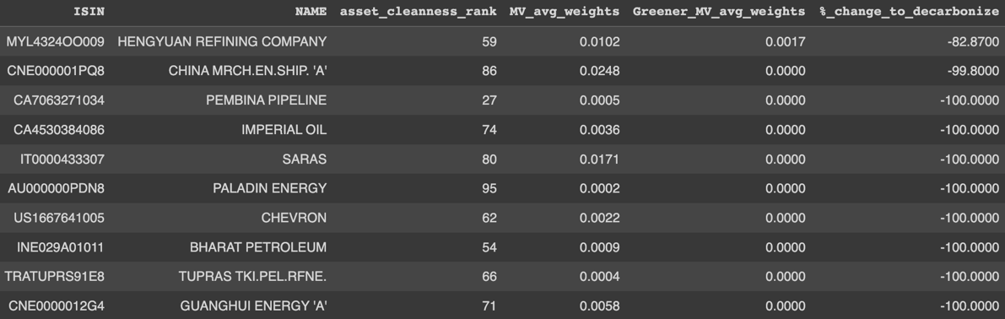

Table 14 Bottom 10 firms in terms of % change of average weight between the MV and Greener MV in 2019

All these firms are essentially dropped by the Greener MV portfolio, and looking at their cleanness rankings, it is easy to infer why: they are big emitters (average cleanness ranking 67.4). For instance, China Merchants Energy Shipping (cleanness rank 86) was almost entirely removed from the Greener MV portfolio, even though it was an important component of the MV portfolio, with a 2.48% weight shrinking to a weight extremely close to 0. This company is one of the largest emitters among our sample and is strongly active in the shipping and logistics industries (also supplying cargo fuel).

When plotting the average weights of both portfolios and coloring them based on the cleanness rank, we get a clear confirmation of this trend: highly carbonized stocks are punished by the Greener MV portfolio, while the MV portfolio does not seem to ‘prefer’ green or non-green stocks.

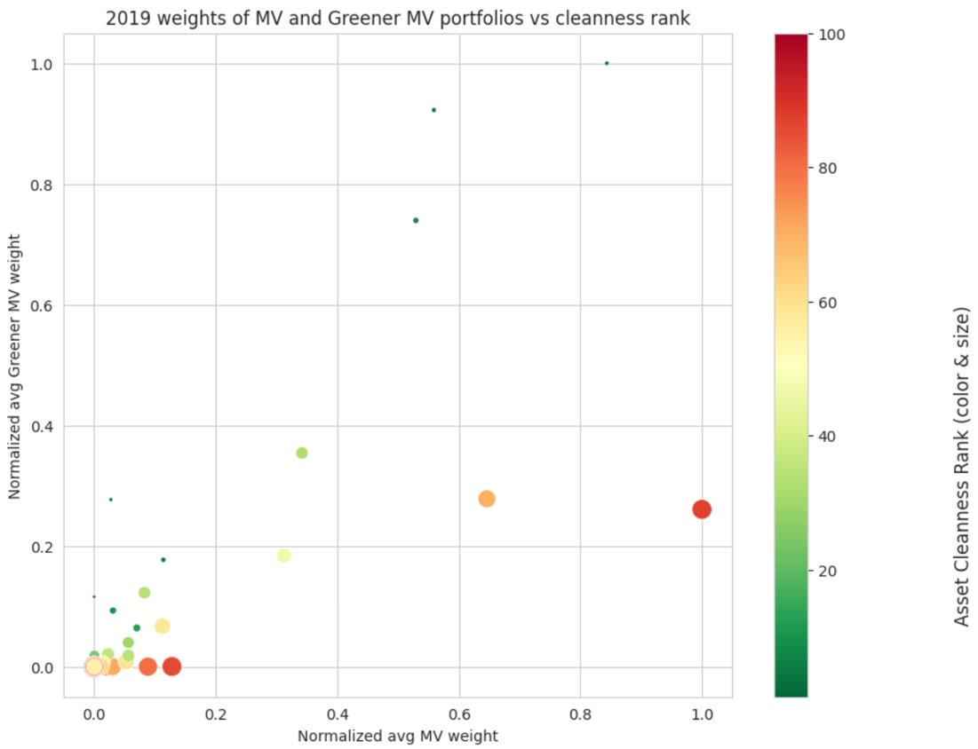

Figure 13 Average (normalized) weights of the MV and Greener MV portfolios, filtered by asset cleanness rank

Interestingly, some stocks are heavily weighed by both portfolios. While the Greener MV portfolio on average favors cleaner stocks, some companies are outliers for both portfolios – they likely have stable, low-volatility returns. Below is a table of the top 10 stocks of each portfolio (by weight):

|  |  |  |  |  |  |
| --- | --- | --- | --- | --- | --- |
| MV portfolio | | | Greener MV portfolio | | |
| Company name | **Avg MV weight (2019)** | **Cleanness rank** | **Company name** | **Avg Greener MV weight (2019)** | **Cleanness rank** |
| QATAR GS.TRAN.NAKILAT | 19.38% | 87 | PETRONAS DAGANGAN | 20.89% | 3 |
| PETRONAS DAGANGAN | 16.35% | 3 | UDR | 19.27% | 4 |
| EXXON MOBIL | 12.53% | 70 | MARICO | 15.45% | 7 |
| UDR | 10.84% | 4 | OIL & GAS DEVELOPMENT COMPANY | 7.40% | 33 |
| MARICO | 10.26% | 7 | EXXON MOBIL | 5.81% | 70 |
| OIL & GAS DEVELOPMENT COMPANY | 6.63% | 33 | PAKISTAN STATE OIL COMPANY | 5.78% | 2 |
| INDIAN OIL | 6.06% | 47 | QATAR GS.TRAN.NAKILAT | 5.45% | 87 |
| CHINA MRCH.EN.SHIP. 'A' | 2.48% | 86 | INDIAN OIL | 3.84% | 47 |
| ULTRAPAR PARTICIPOES ON | 2.20% | 5 | ULTRAPAR PARTICIPOES ON | 3.70% | 5 |
| IDEMITSU KOSAN | 2.17% | 58 | CABOT OIL & GAS 'A' | 2.56% | 34 |

Table 15 Top 10 firms of the MV portfolio (left) and Greener MV portfolio (right) in 2019, by average weight

8 firms (those with colored text) are part of both our portfolios’ top 10 assets. PETRONAS DAGANGAN, a Malaysian energy company that specializes in Liquified Natural Gas, is the combined favorite stock of the two portfolios in 2019, as it has a comparatively low carbon intensity, and relatively stable returns. UDR, MARICO, Nakilat (Qatar Gas Transport Company), and Exxon Mobil are other very prominent assets, even though Nakilat and Exxon Mobil are part of the worst half of the sample firms (cleanness ranks 87 and 70, respectively). They are however large, stable, and diversified companies, which makes them an ideal asset for volatility minimization.

# Appendices

## Appendix A : Bottom 10 and Top 10 carbon intensity across 100 randomly selected assets

|  |  |  |  |  |  |
| --- | --- | --- | --- | --- | --- |
| Bottom 10 | ISIN | NAME | Carbon Intensity | Volatility | Annualized Average return |
| 1 | CNE0000019T2 | **OFFS.OIL ENGR. 'A'** | 68.587 | 0.422 | 0.052 |
| 2 | PK0022501016 | **PAKISTAN STATE OIL COMPANY** | 90.955 | 0.416 | -0.002 |
| 3 | MYL5681OO001 | **PETRONAS DAGANGAN** | 102.192 | 0.230 | 0.098 |
| 4 | US9026531049 | **UDR** | 105.432 | 0.322 | 0.129 |
| 5 | BRUGPAACNOR8 | **ULTRAPAR PARTICIPOES ON** | 119.633 | 0.686 | -0.050 |
| 6 | GB00B5N0P849 | **WOOD GROUP (JOHN)** | 171.881 | 0.383 | -0.053 |
| 7 | INE196A01026 | **MARICO** | 187.440 | 0.321 | 0.163 |
| 8 | US03957W1062 | **ARCHROCK** | 271.472 | 0.478 | 0.036 |
| 9 | SE0000825820 | **LUNDIN ENERGY** | 273.930 | 0.471 | 0.227 |
| 10 | JP3294460005 | **INPEX** | 274.589 | 0.332 | 0.044 |

Table 7 Bottom 10 carbon intensity ranking.

And here is the top 10:

|  |  |  |  |  |  |
| --- | --- | --- | --- | --- | --- |
| Top 10 | ISIN | NAME | Carbon Intensity | Volatility | Annualized Average Return |
| 1 | CNE1000002R0 | **CHINA SHENHUA EN.CO.'H'** | 9452.365 | 0.389 | 0.043 |
| 2 | RU000A0B90N8 | **RASPADSKAYA** | 3126.914 | 0.679 | 0.384 |
| 3 | CNE100000528 | **CHINA COAL ENERGY 'H'** | 2785.027 | 0.565 | -0.037 |
| 4 | RU0007661625 | **GAZPROM** | 2524.986 | 0.420 | 0.191 |
| 5 | CA09784Y1088 | **BONAVISTA ENERGY DEAD - DELIST.14/08/20** | 2369.308 | 0.346 | -0.402 |
| 6 | AU000000PDN8 | **PALADIN ENERGY** | 1922.800 | 0.719 | 0.158 |
| 7 | CA1363851017 | **CANADIAN NATURAL RES.** | 1855.834 | 0.413 | 0.031 |
| 8 | LU0156801721 | **TENARIS** | 1731.329 | 0.445 | -0.018 |
| 9 | US12653C1080 | **CNX RESOURCES** | 1672.077 | 0.459 | -0.196 |
| 10 | CA07317Q1054 | **BAYTEX ENERGY** | 1642.395 | 0.418 | -0.307 |

Table 8 Top 10 carbon intensity ranking.

1. Note: no single stock had an average weight of exactly 0 in either portfolio in 2019.